-Nikesh Deuja-
Worksheet-0 (Concepts and Technologies of AI)

Task 1. Classify Study Time:
1. Create empty lists for study time classifications:
(a) Low: less than 3 hours.
(b) Moderate: between 3 and 5 hours.
(c) High: more than 5 hours.

2. Iterate over the time data list and add each study hour to the appropriate category.
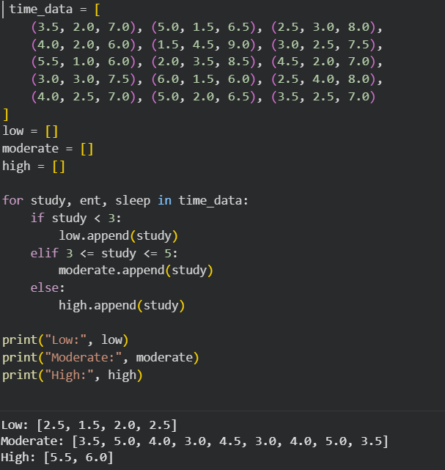
3. Print the lists to verify the classifications.

Task 2. Based on Data – Answer all the Questions:
1. How many days had low study time?
(a) Hint: Count the number of items in the low study list and print the result.
2. How many days had moderate study time?
3. How many days had high study time?

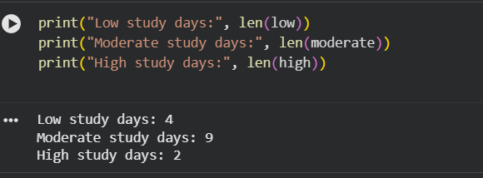

Task 3. Convert Study Hours to Minutes:
Convert each study hour value into minutes and store it in a new list called study_minutes. Formula: Minutes = Hours × 60
1. Iterate over the time_data list and apply the formula to the study hours.
2. Store the results in the new list.
3. Print the converted values.

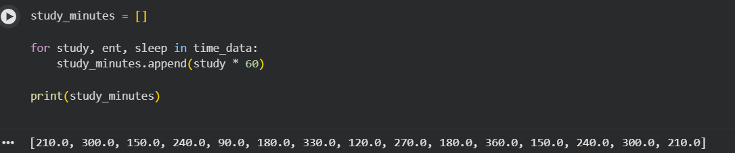

Task 4. Analyze Average Time Use:
Scenario: Each record contains daily hours of study, entertainment, and sleep.
1. Create empty lists for study_hours, entertainment_hours, and sleep_hours.
2. Iterate over time_data and extract values into each list.
3. Calculate and print:
(a) Average hours spent studying.
(b) Average hours spent on entertainment.
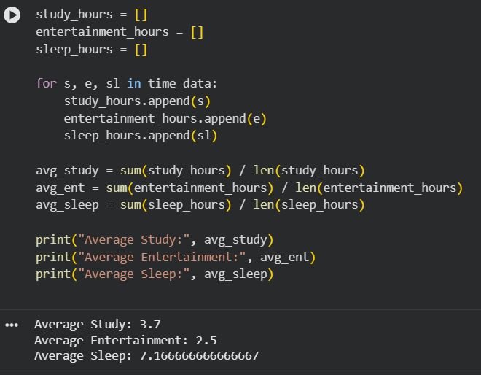
(c) Average hours spent sleeping.

Task 5. Visualization - Study vs Sleep Pattern:
1. Import matplotlib.pyplot as plt.
2. Plot a scatter plot with:
• x-axis: Study hours
• y-axis: Sleep hours
3. Add labels, title, and color.

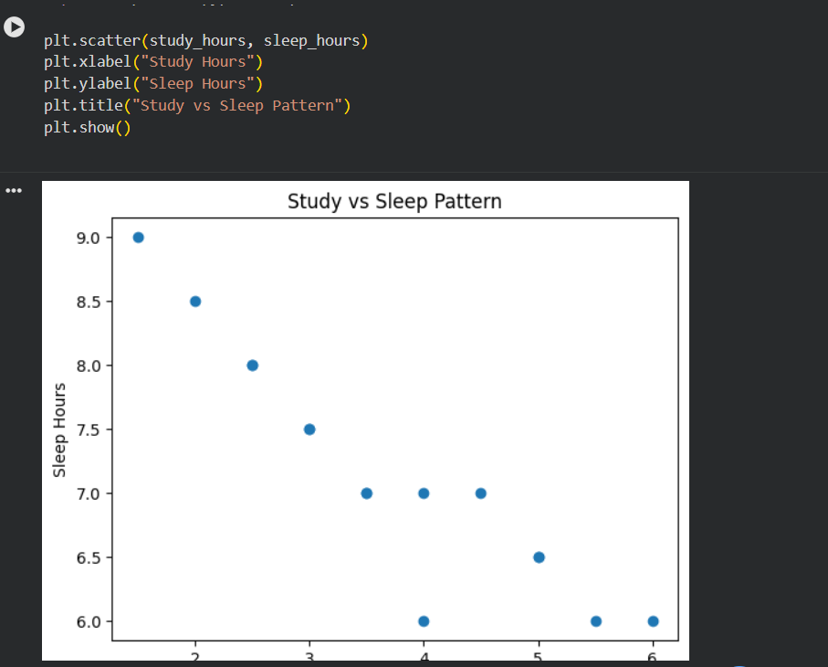

RECURSION TASKS
Task 1 - Sum of Nested Lists:
Scenario: You have a list that contains numbers and other lists of numbers (nested lists). You want to find the total sum of all the numbers in this structure.
Task:
• Write a recursive function sum_nested_list(nested_list) that:
1. Takes a nested list (a list that can contain numbers or other lists of numbers) as input.
2. Sums all numbers at every depth level of the list, regardless of how deeply nested the numbers are.
• Test the function with a sample nested list, such as
nested_list = [1, [2, [3, 4], 5], 6, [7, 8]].
The result should be the total sum of all the numbers.

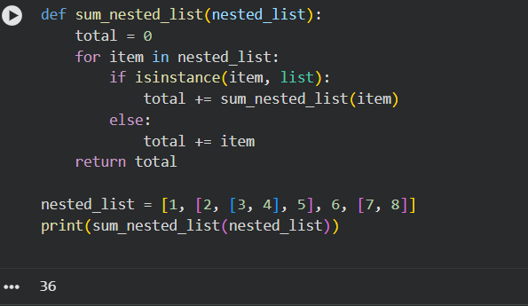

Task 2 - Generate All Permutations of a String:
Scenario: Given a string, generate all possible permutations of its characters. This is useful for understanding backtracking and recursive depth-first search.
Task:
• Write a recursive function generate_permutations(s) that:
– Takes a string s as input and returns a list of all unique permutations. • Test with strings like ”abc” and ”aab”.
print(generate_permutations("abc"))
# Should return [’abc’, ’acb’, ’bac’, ’bca’, ’cab’, ’cba’]

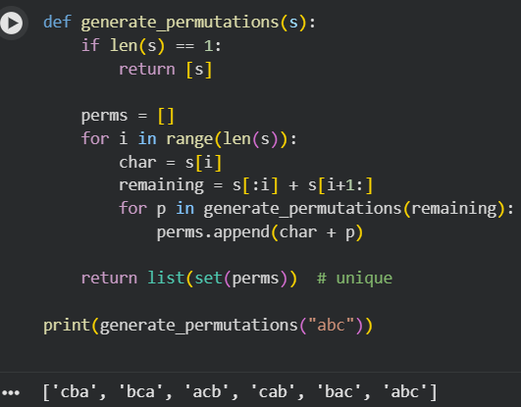
Task 3 - Directory Size Calculation:
Directory Size Calculation Scenario: Imagine a file system where directories can contain files (with sizes in KB) and other directories. You want to calculate the total size of a directory, including all nested files and subdirectories.
Sample directory structure.
# Sample directory structure
directory_structure = {
"file1.txt": 200,
"file2.txt": 300,
"subdir1": {
"file3.txt": 400,
"file4.txt": 100
},
"subdir2": {
"subsubdir1": {
"file5.txt": 250
},
"file6.txt": 150
}
}
Task:
1. Write a recursive function calculate_directory_size(directory) where:
• directory is a dictionary where keys represent file names (with values as sizes in KB) or directory names (with values as another dictionary representing a sub directory).
• The function should return the total size of the directory, including all nested subdirectories.
2. Test the function with a sample directory structure.

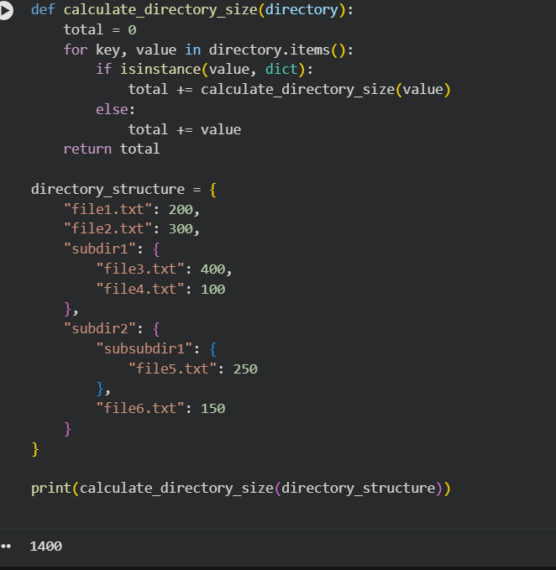

Dynamic Programming Tasks
1. Write a function min_coins(coins, amount) that:
• Uses DP to calculate the minimum number of coins needed to make up the amount.
2. Test with coins = [1, 2, 5] and amount = 11. The result should be 3 (using coins [5, 5, 1]).
Sample Code - Coin Change Problem.
def min_coins(coins, amount):
"""
Finds the minimum number of coins needed to make up a given amount using dynamic programming.
This function solves the coin change problem by determining the fewest number of coins from a given set of coin denominations that sum up to a target amount. The solution uses dynamic programming(tabulation) to iteratively build up the minimum number of coins required for each amount.
Parameters:
coins (list of int): A list of coin denominations available for making change. Each coin denomination is a positive integer.

amount (int): The target amount for which we need to find the minimum number of coins . It must be a non-negative integer.
Returns:
int: The minimum number of coins required to make the given amount.
If it is not possible to make the amount with the given coins, returns -1. Example:
>>> min_coins([1, 2, 5], 11)
3
>>> min_coins([2], 3)
-1
"""
dp = [float(’inf’)] * (amount + 1)
dp[0] = 0
for coin in coins:
for i in range(coin, amount + 1):
dp[i] = min(dp[i], dp[i - coin] + 1)
return dp[amount] if dp[amount] != float(’inf’) else -1

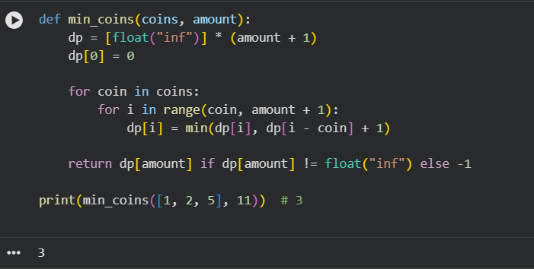
Task 2 - Longest Common Subsequence (LCS):
Scenario: Given two strings, find the length of their longest common subsequence (LCS). This is useful in text comparison.
Task:
1. Write a function longest_common_subsequence(s1, s2) that:
• Uses DP to find the length of the LCS of two strings s1 and s2.
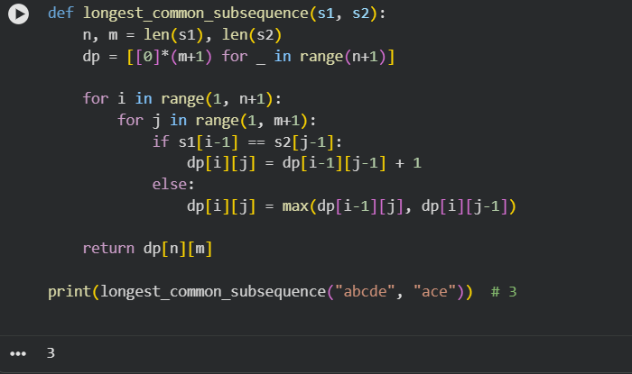
2. Test with strings like "abcde" and "ace"; the LCS length should be 3 ("ace")

Task 3 - 0/1 Knapsack Problem:
Scenario: You have a list of items, each with a weight and a value. Given a weight capacity, maximize the total value of items you can carry without exceeding the weight capacity. Task:
1. Write a function knapsack(weights, values, capacity) that:
• Uses DP to determine the maximum value that can be achieved within the given weight capacity.
2. Test with weights [1, 3, 4, 5], values [1, 4, 5, 7], and capacity 7. The result should be 9.

